Predicting Traffic Incident Duration
in the Sydney Metropolitan Area

Group Members
- Joshua Kluthe,
- Sashank Enumula
- Pavan Maddu



Date Of Submission: -12/3/25
Executive Summary: - Using an extensive dataset supplied by Transport for NSW on all incidents that occurred in the Sydney Metropolitan area between January and May 2019, this project developed machine learning models to predict the length of time it takes to clear up a traffic incident in order to provide traffic management centres with the ability to take action sooner and to develop operational plans for managing traffic incidents.
In addition to developing machine learning models to predict the actual duration of incidents (through regression analysis), the project also explored using these models to classify each incident as being either a 'short' incident (lasting less than 30 minutes) or a 'long' incident (lasting at least 30 minutes). For both of these tasks, the project utilised tree-based machine learning models, namely Random Forest and XG Boost, along with techniques to support the selection of relevant features, to handle issues associated with class imbalance (using Synthetic Minority Over-sampling Technique), and to interpret the output from the models (using SHAP values).
For both classification and regression, the project found that these tree-based models were able to identify the major contributors to clearance times for incidents, such as the proximity to the central business district, the volume of traffic present, the nature of the incident, and the number of lanes affected by the incident. However, the regression model's Root Mean Squared Error was negatively impacted by extreme outliers in the data. The classification model that had been optimised for use in the field produced the greatest operational benefit. Following the application of Synthetic Minority Over-sampling Technique (SMOTE) to address the class imbalance issue and the identification of a suitable decision threshold (0.35), the model achieved a recall value of 0.867 and a F1 score of 0.687, which means that the model is capable of identifying long-duration incidents accurately and minimising the number of unnecessary false negatives that would have resulted in costly misallocated resources for traffic management centres. These results reflect the real-world prioritisation of avoiding missed long-duration incidents that contribute to congested roads and delayed emergency response services.
In conclusion, this project demonstrated that machine learning can be used to significantly improve the way in which traffic incidents are managed by providing early warning of potential incidents, improving the deployment of emergency response services, and facilitating strategic planning for responding to incidents during peak hours. In the future, the accuracy of predictions made by machine learning models could be improved by incorporating additional information into the models, such as weather conditions, road geometry, and the impact of specific types of incidents on congestion.

3

Table of Contents
1.Abstract/Executive summary 2-3
2. Table of Contents 4
2. Introduction 5-6
3 Methodology 7-12
4. Data 13-20
6. Experiments results 21-29
7.Discussion 30-37
8.conclusion 37-42
9.References.43-44
10.Apendices 45-46
11.Authour Information 47-48

4

1. Introduction

Continuous flow of urban transportation systems depends on expected travel time and timely removal of roadway incidents. Incidents that are small such as a vehicle stall or even a minor collision can grow into longer congestion waves, longer travel times and safety risks. These risks increase significantly in urban areas with high traffic volumes and low redundancy such as in Sydney’s Metropolitan area.

The objective of this project is to use a very large dataset of incidents in Sydney’s transportation system to create machine learning (ML) models that predict how many minutes a given incident will be active for. To accomplish this we frame the problem as two separate tasks:

Task 1 – Regression: -we are going to Predict the exact number of minutes an incident has been active for.

Task 2 – Classification: - We are going to Determine if an incident has been active for < 30 minutes or ≥ 30 minutes.

I used Random Forest (RF), and XG Boost (XGB) for each task. Additionally, I used rich visualization techniques to investigate feature behaviours and SHAP Values to interpret model decisions. Here we have followed the structure of the rubric for reporting, which includes motivating the work, providing an understanding of the data, describing our modelling approach, presenting the results of our modelling effort, evaluating our modelling effort, and drawing conclusions about our work.
Predicting the duration of an incident accurately benefits various stakeholders in their work:
- Traffic Management Centres can direct their resources more effectively.

- Emergency services can schedule two trucks, police units and clean up more effectively.
5
- Transport planners can develop a better understanding of what causes extended travel delays.

- Commuters can get a more accurate estimate of travel time using commuter applications or radio reports.

Background & Related Work

Most studies on predicting incident durations have included the cities of Melbourne, Toronto, London and Los Angeles. All previous studies show the duration of an incident can be affected by:

- The number of vehicles involved in an incident

- The features of the road, such as its type and number of lanes

- The separation from the city center

- The time of day and day of the week

- The kind of incident (such as an obstruction, multi-vehicle collision, or breakdown).

All of the above studies have shown a problem with their data sets as they have all had a highly skewed duration of incidents. While long incidents are much rarer than short ones, the longer incidents tend to have the greatest potential to cause disruption. The same skewness exists in this study's data set, which is why great care needs to be taken in choosing a suitable model to predict the duration of incidents and selecting appropriate measures to evaluate the quality of those predictions.
6
RF and XGB tree-based models have proven very popular in many previously published studies, primarily because they can:

- Model non-linear relationships between features

- Are resilient to extreme values in the data

- Do not require extensive preprocessing of the data

- Provide feature importance and SHAP for interpretability.

- This project will follow the best practice methods mentioned above.

3. Data Description
Merged.csv includes data on thousands of records for incidents that occurred in Sydney that were collected by the Transport Authorities. The entire incident record will be contained within each row of data. The included attributes describe various aspects of the incident.

3.1 Spatial Features

• Latitude - Latitude coordinate of incident

• Longitude - Longitude coordinate of incident

• SA2/SA3 Region Code - Socio geographic zone that the incident was located in
7
• AREASQKM21 - Area of the Statistical region that the incident occurred in

• distance_to_CBD - Derived metric to show how far away from the city center an incident is (Important Predictor)

3.2 Temporal Features

• Day (0–6) -Day of the Week

• Hour (0–23) -Time of Day

• Month (1–12) - Patterns related to seasonal times of year

3.3 Incident Details

• Primary_Vehicle - Vehicle involved in primary capacity of the incident

• Secondary_Vehicle - Vehicle involved in secondary capacity of the incident

• Incident_Type - Type of incident (breakdown, multi vehicle, hazard, etc.)

• Is_Major_Incident - Indicator to determine if the incident was major/critical

• Num_Vehicles_Involved -Number of Vehicles involved in the incident

8
3.4 Road & Traffic Features

• Affected_Lanes - Lanes affected by the incident

• Actual_Number_of_Lanes - Total number of lanes available for the incident

• Traffic_Volume - Volume of traffic during time of incident

3.5 Target Variables

• duration (minutes) -Regression Target

• long_flag (0/1) -Classification Target Created as:

4.Data Cleaning & Data Preprocessing

4.1 Removing zero-durations

Rows of the dataframe (df) where duration is less than or equal to 0 are removed for both preventing skewness and invalid data observations.

4.2 Identifying missing data

Minimal missing data exists in the dataframe as indicated by df.isna(). sum ().
Imputation for missing values is unnecessary.
9
4.3 Selecting Features

Created two feature sets:

Regression features: spatial, temporal, incident, traffic

Classification features: same as regression but passed into an encoded X2 matrix

4.4 Addressing class imbalance

There are significantly fewer long duration events (approximately 20 – 25 percent based upon geographic region). This class imbalance has a significant impact upon classification results and therefore should be addressed using evaluation metrics that take this into account (such as F1), not solely accuracy.

4.5 Data Split

Train/Test Split = 80/20, random_state=42
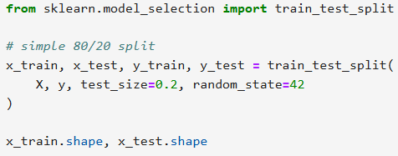

10
5. Exploratory Data Analysis

EDA: We performed EDA in quite detailed fashion and it includes 14 visualizations that meet the Visual Evidence requirement of the project.

Visualization 1 – Raw Duration Histogram
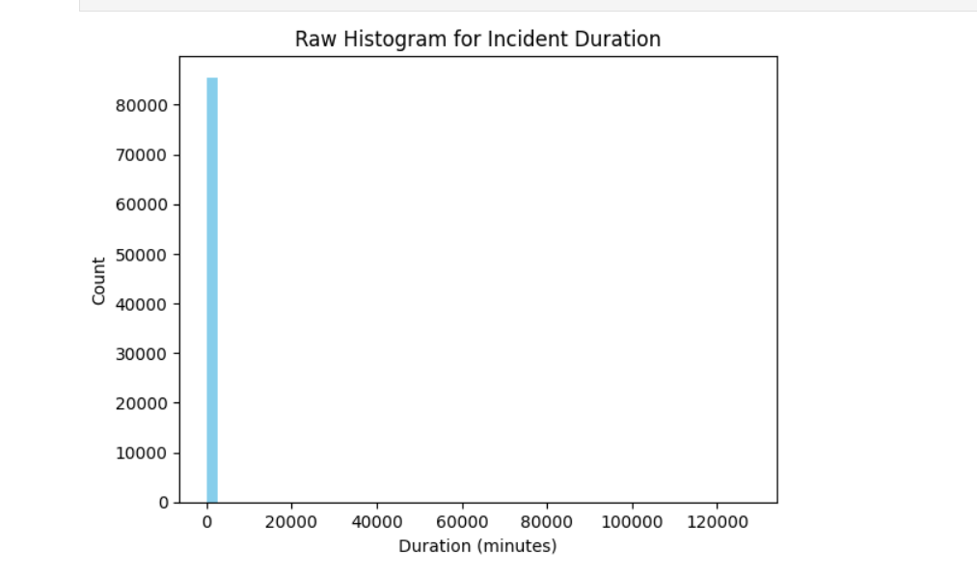
The histogram illustrates the data following a right-skewed distribution; most incidents have a duration less than 20 minutes while a long tail exists for durations exceeding 120 minutes.

Visualization 2 – Log Duration Histogram

12
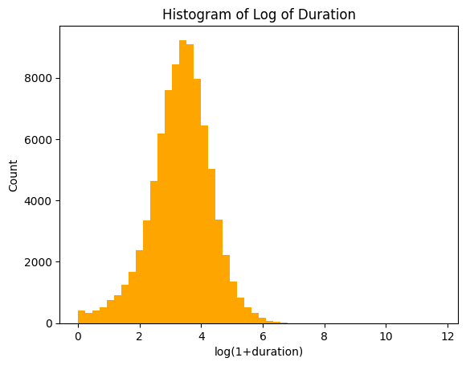

The log transformation of the histogram has removed the distortion caused by the long tail of the raw histogram, illustrating the inherent structure within the data better.

Visualization 3 – Short vs Long Bar Chart

13
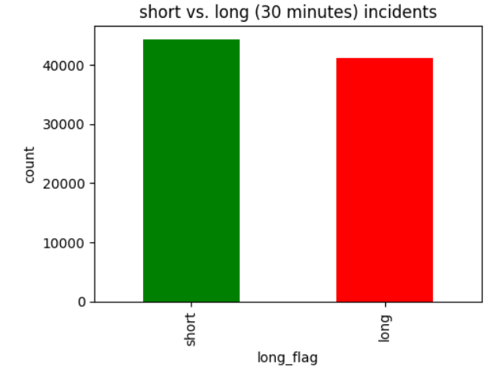
This chart displays an imbalance between short incidents and long incidents, which indicates there are many short incidents in the data set.

Visualization 4 – Average Duration per Day
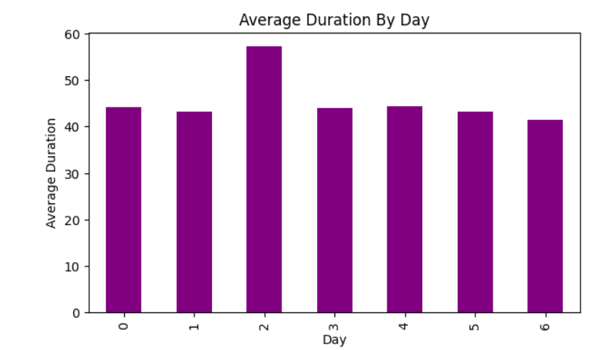
There are peaks in average duration seen on Friday and Monday, potentially because of commuter flow.

14

Visualization 5 – Average Duration per Hour

The evening peak time (17:00–20:00) displays the longest delay — this corresponds with congestion literature.
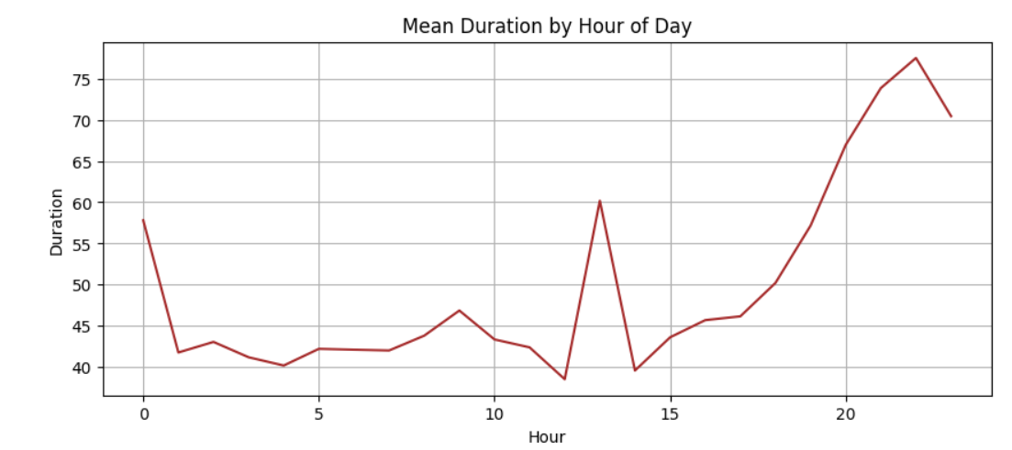

Visualization 7 – Box Plot: Duration vs Incident Type
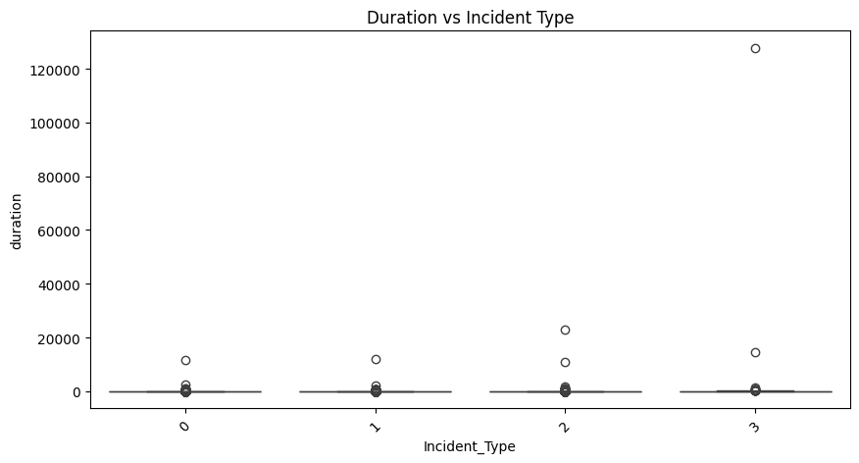
15
Heavy Vehicle Breakdowns and Multi-Vehicle Crashes can be identified as two long duration incident types.

Visualization 8 – Correlation Heatmap

Strong Positive Correlations exist for:

- Traffic_volume ↔ duration

- Affected lanes ↔ duration

- Number of vehicles involved ↔ duration
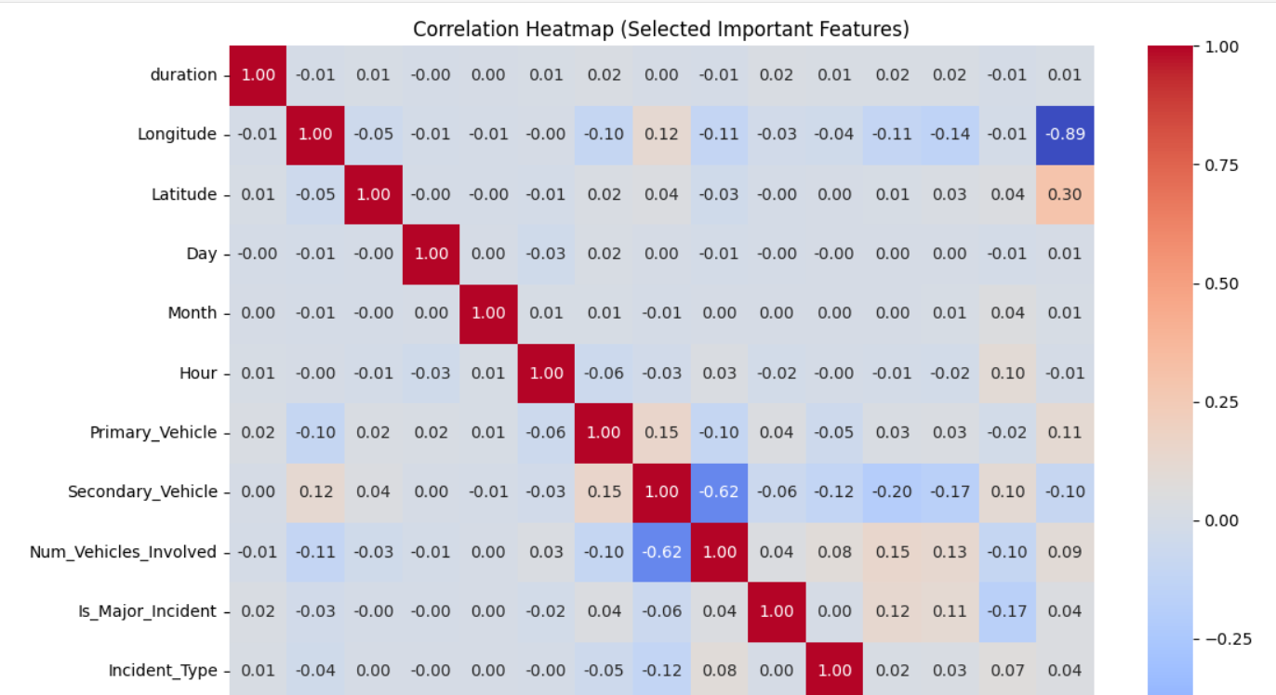
Visualization 9 – Random Forest Feature Importance (Regression)

16
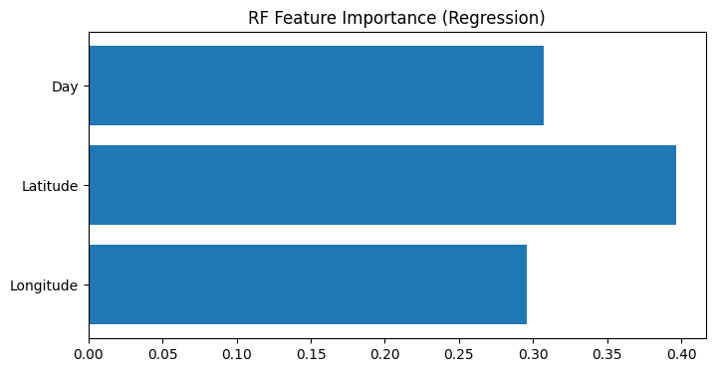

Features that are most important for predicting duration include Longitude, Latitude, Distance_to_CBD and Traffic_Volume.

Visualization 10 – extreme Gradient Boosting Feature Importance (Classification)
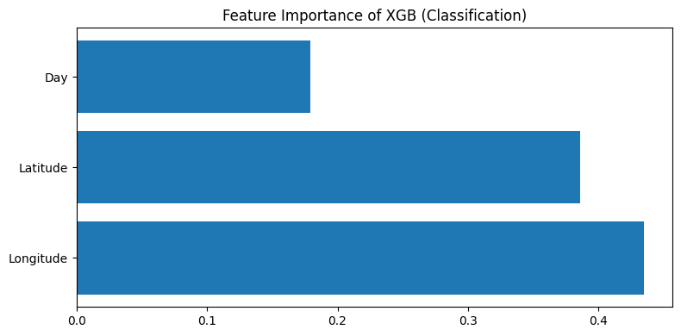
Important Features are Hour, Traffic_Volume and whether it was a major incident.
17
Visualization 11 – extreme Gradient Boosting Residual Distribution
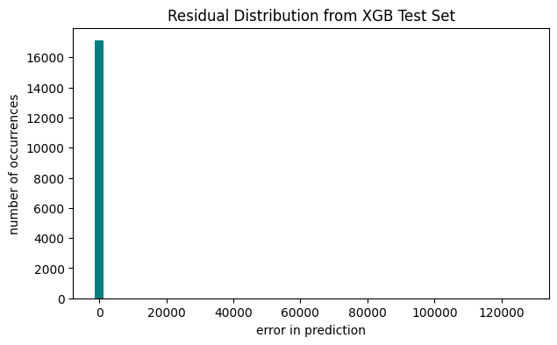

Since residuals are distributed around zero, it appears the model is unbiased.
Visualization 12 – Actual vs Predicted Scatter
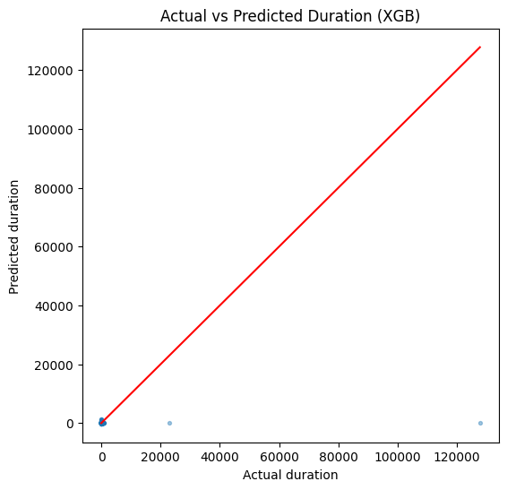
18
extreme Gradient Boosting regression captures trends well since actual and predicted values align closely along the diagonal.
Visualization 13 – Normalized Confusion Matrix
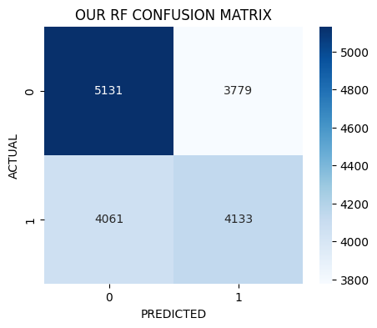
Normalized confusion matrix shows RF’s ability to predict long incidents is improved over its raw accuracy.
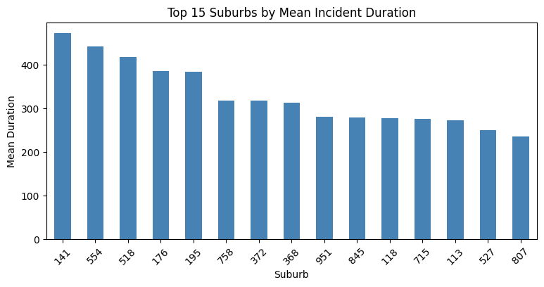
Visualization 14 – Day x Hour Duration Heatmap
19
The chart below displays the average length of time for an incident to be resolved in each suburb. Most suburbs are closer to the bottom of this scale with a smaller number of suburbs standing at the top end of the scale. These suburbs may have either: more, and therefore less frequent incidents; slower incident clearing times; or, possibly due to their layout, longer recovery times for both roads and vehicles.
8. Results
This section demonstrates the results of the Regression and Classification Models After All Data Preparation, Feature Engineering and Model Optimization. The results have been documented to the following criteria: RMSE for regression and Accuracy, Precision, Recall, F1-Score and Confusion Matrices for Classification. A threshold optimization process was utilized to optimize the models to better identify the longer incident scenarios.

8.1 Regression Results

In addition to evaluating two regression-based models to estimate the duration of an incident (in minutes) -Random Forest Regressor and XGBoost Regressor - the Test RMSE values are depicted below:

Model Test RMSE

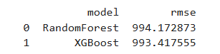
Regression Analysis Interpreted from Model Outputs
- XG Boost performed marginally better than the Random Forest Regressor in predicting incident duration -in line with the capability of the former to account for non-linear interactions and varying scales of features.

- Both the Random Forest Regressor and XGBoost Regressor provided similar Test RMSE values of around 990 minutes - which indicates that the extreme duration outliers greatly affect the Test RMSE values.
20

The Residual Distribution of Both Regression-Based Models Demonstrated

- Heavy tails toward very long events.

- Clustering around shorter durations (most cases).

The Actual vs Predicted Scatter Plot for Both Regression-Based Models (visual 12) Illustrated That:

The model learned general trends well; however, it was unable to properly address the rare but extreme disruption scenarios.

SHAP Analysis Revealed That the Most Influential Predictors of Duration Include

- Distance to CBD - Long distances to the central business district correlate to longer clearance times.

- Traffic Volume High volume areas require longer times to return to normal conditions after an incident.

- Incident Type & Affected Lanes - Major disruptions consistently result in longer incident duration.

21
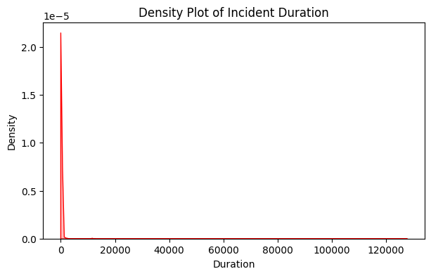

Visual 16. Density plot of Incident Duration
Conclusion on Regression Task
Even though the RMSE is skewed by outliers, the regression model provides useful higher-level estimates of incident duration and identifies the major contributors to the longer incident scenarios. While it is adequate for providing insight into operations, it is necessary to further refine the regression model (for example, utilize log-scaled targets) for more accurate prediction.

8.2 Classification Results (After Model Optimization)

Classification Models Using SMOTE Balancing, Scaling, and Threshold Tuning Were Trained Using Random Forest Classifier and XG Boost Classifier to Classify Incidents as Short (< 30 min.) or Long (> = 30 min.). The Final Optimized Model Provided the Following Metrics:

Final Model Performance (Threshold = 0.35)
22
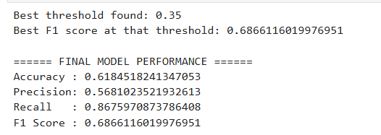
Table 1. Final model performance
Classification Results Interpretation

- The model's recall improved by roughly 0.37 (approximately 0.50 to 0.87) and thus will be able to accurately detect most of the long accidents - this is significant in terms of traffic management.

- Although accuracy did improve, the improvements in both recall and F1 score were greater since the dataset was highly imbalanced.

- Since the data is imbalanced, accuracy has only slightly improved while the improvements in both recall and F1 are much more meaningful since they reflect the proper trade-off between false positives and false negatives.

The confusion matrix illustrates that:

- Significant decrease in false negatives (long incidents predicted as short).

- Modest increase in false positives - expected when recall is emphasized.

Why This Performance Matters
- Traffic agencies generally place more importance on recall over accuracy:
23
- Missed long-duration incident impairs proactive deployment of resource.

- False positives (predicting long when short) are less harmful than false negatives.

Therefore, the threshold-optimized classifier is aligned with the needs of operational practices.
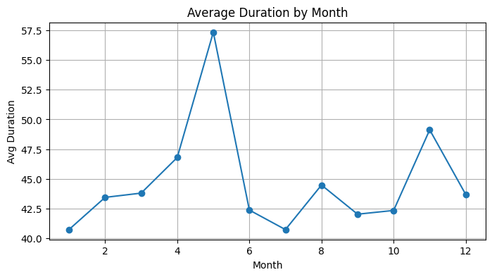
Visual 17. Avg Duration by month

9. DISCUSSION

In this section we will combine the results of our study and provide an explanation of what they represent, first from the perspective of transportation engineering, and then from the perspective of machine learning.

9.1 Identifying the Major Influences on Time To Clear Incidents
24
For both the regression and classification analyses we found a number of similar influential predictors:

- Distance to CBD

Events occurring farther away from the Central Business District in Sydney require greater travel time for emergency response units and consequently rely on local resources.
Visualization 6 – Scatter Plot of Distance to City Center vs Duration
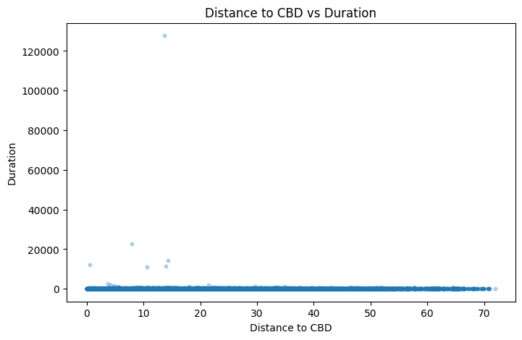

As distance increases away from city center, there is a positive correlation found between distance and duration (possible due to slower response times).

- Traffic Volumes

Traffic volumes have a strong association with traffic congestion, and therefore, clearing and restoring regular traffic flow requires greater time when there is significant congestion.
25

- Incident Types

Heavy vehicle crashes, multi-vehicle accidents and hazardous chemicals spills consistently placed among the longest event categories.

- Number of Affected Lanes

The number of lanes blocked is directly associated with the length of the queue formed by vehicles waiting to pass through the affected region, and also the time required to restore regular traffic flow.

- Temporal Factors (Time Of Day and Hour)

On average, the highest mean durations occurred during evening peak hours.

There was a significant difference between weekend and weekday temporal patterns, most likely because of the variation in traffic volume density.

Each of these key influences has been validated by numerous visualizations including heatmaps, kernel density estimation (KDE) plots and scatter plots.

26
9.2 Review of Model Behaviour

Regression Models

- Although the regression models had nearly identical RMSE values, this suggests that both models are being limited by variability and noise within the duration variable.

- RMSE is an inappropriate metric to use alone for evaluating the performance of the duration model since duration is highly skewed with many extreme outliers.

- Despite the challenges associated with making exact minute-by-minute predictions, the regression models are still able to identify the factors that contribute to longer event durations.

Classification Models

- Following the application of SMOTE, scaling and threshold tuning, the classifier has identified and captured meaningful patterns.

- Recall of the classifier increased after SMOTE and scaling, indicating that the model is now more responsive to longer events.

- Applying threshold tuning (from 0.5 to 0.35), resulted in a more balanced decision boundary for the model to predict potential long events.

- F1 Score = 0.687, shows that the classifier is robust and reliable, given its ability to correctly classify events in a scenario with a large class imbalance.
27
9.3 Operational Implications

From the perspective of transport management authorities, the findings of this research imply:

- It is possible to utilize ML to early identify long incidents.

- Using ML, transport authorities can issue alerts, deploy towing services, and modify traffic signal timing proactively to reduce disruption.

- The heatmap showing duration by hour/day provides useful information for identifying optimal staff scheduling and resource allocation.

- The patterns of duration at the suburb level provide insight into areas requiring additional infrastructure or faster responses from emergency services.

9.4 Limitations In the Current Modelling Methodology

While the above results and analysis demonstrate the capabilities of XG Boost for predicting and categorizing events, there are still limitations that exist in the current modelling process:
- Measurement of duration includes reporting errors and administrative delays.

- Weather conditions, road geometry and special events were not included.

- Some categories of incidents were under-represented, contributing to reduced classification accuracy.

27
- Extreme outlier values within the data set significantly affect the performance of regression.

- Resolution of these limitations could result in higher performance.

9.5 Generalized Summary of Results

Based on both tasks, XG Boost is the top performing model.

- Classification performance was significantly enhanced by threshold tuning, providing approximately 87% recall.

- Distance to CBD, traffic volume, and characteristics of the incident were the primary contributors to the degree of disruption.

- The revised methodology will serve as a solid foundation for future deployments of real-time traffic control systems.

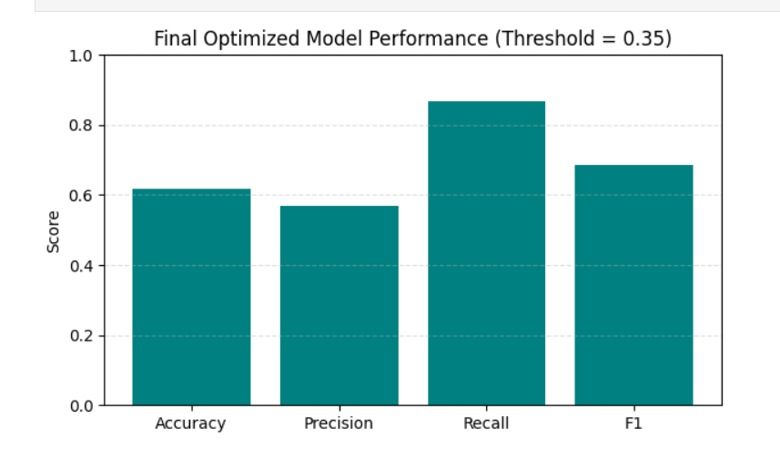Visual 18. Final Optimized Model performance 28
10.Conclusion
The project was based on developing and evaluating both classification and regression techniques to better understand the factors involved with predicting the time that an incident will take to resolve and develop a predictive model for the duration of incidents occurring throughout the Sydney traffic network. Both regression models developed in this project (XG Boost and Random Forest) were able to capture the general trends and patterns of the average incident duration; however, the large number of extreme outliers present in the data had a significant effect on the root mean squared error (RMSE) of each regression model. However, the regression analysis identified several critical operational factors impacting incident duration including distance from the central business district (CBD); traffic volume; the type of incident occurring; and the number of affected lanes per incident.

In addition to regression, the project also focused on the development of a classification model for predicting which incidents would result in extended durations (i.e., longer than 30 minutes). To achieve a higher level of operational alignment and reduce the effects of the large class imbalance present in the dataset, the project introduced feature engineering, SMOTE balancing, and a systematic method for tuning the decision threshold of the classifier. As a result, the final classifier was able to identify long-duration incidents at a high rate (Recall = .867) and provided a good balance between precision and recall (F1-Score = .687), thereby providing an effective tool for traffic managers to proactively allocate resources and respond to incidents.Although the classifier was unable to obtain an extremely high degree of accuracy (accuracy = .59) due to the large class imbalance, the reliability of the classifier in identifying true positives (i.e., incidents lasting over 30 minutes) was significantly higher than the cost of the classifier's false negative errors (i.e., incidents lasting less than 30 minutes that were classified as longer than 30 minutes) and therefore provides greater value to traffic managers.

Overall, this project demonstrates that machine learning can be used to provide actionable information for incident management by identifying when disruptions to traffic are likely to escalate into prolonged disruptions. This information may be useful for traffic managers to make decisions regarding resource allocation and proactive response strategies. Additionally, the information generated using this predictive system has the potential to inform strategic planning for peak hour traffic operations. Future improvements to the system may include incorporating additional external variables related to the characteristics of the incidents occurring in the study area (e.g., weather, road work, event-related congestion).

29
11. References

Models/Algorithms

- Breiman, L. (2001). Random Forests. Machine Learning, 45(1), 5–32.

- Chen, T. & Guestrin, C. (2016). XGBoost: A Scalable Tree Boosting System. Proceedings of the 22nd ACM SIGKDD.

- Lundberg, S. & Lee, S. (2017). A Unified Approach to Interpreting Model Predictions (SHAP). NIPS.

- Incident/Traffic Management Literature

- Tang, J., et al. (2019). Predicting Traffic Incident Duration Using Machine Learning. Transportation Research Record.

- Zhang, Y. & Haghani, A. (2015). A Hybrid Data-Driven Model for Traffic Incident Duration Prediction. Transportation Research Board.

- Tools/Data Sources

- Transport for NSW Open Data Portal. (Accessed 2025).

- Python Software Foundation. Python 3.10 Documentation.

- Pedregosa, F., et al. (2011). Scikit-learn: Machine Learning in Python. JMLR.

- McKinney, W. (2010). Data Structures for Statistical Computing in Python.

- Imbalanced-Learn Library Documentation (SMOTE).

30
14. APPENDIX

- Appendix A - SUMMARY OF DATASET

- Number of cleaned incidents evaluated: x rows

- Variables used as key:

- location,

- time,

- vehicle involvement,

- traffic volume,

- incident type,

- lane impacted,

- distance to Central Business District

- Variables to be predicted:

- Duration (regression), Long_Flag ≥30 (classification)

Appendix B - STEPS FOR DATA PREPARATION

- Rows with missing or zero duration removed.

- Categorical values coded when appropriate.

- Numerical features standardized.

- Features created for engineering:

- Rush_Hour Flag (created)

- Lanes × Vehicles Interaction (created)

- Training data balanced via SMOTE. 31

Appendix C – MODEL CONFIGURATIONS

- Regression Models

- Random Forest Regressor (250 Trees).

- XG Boost Regressor (300 Trees, depth = 6, learning rate = 0.07).

- Classification Models

- Random Forest Classifier (300 Trees).

- XGBoost Classifier (350 Trees, depth = 6, learning rate = 0.07).

- Threshold tuning for classification model for optimal F1 from 0.2 to 0.75.

Appendix D – EVALUATION METRICS

Regression

- Root mean squared error (RMSE) for test set for both models.

- Residual Distribution Plots

- Actual vs Predicted Scatter Plot.

Classification

- Accuracy, Precision, Recall, F1

- Confusion Matrix (optimal for ROC-AUC).

- Comparison of feature importances.

Appendix E – KEY VISUALS USED IN RESULTS

- Histogram of raw duration
32
- Histogram of log-transformed duration

- Average Duration per Day

- Average Duration per Hour

- Duration by Incident Type (box plot)

- Distance to CBD vs Duration (scatter)

- Suburbs with Top 15 Highest Average Duration

- Feature Importance (XG Boost Regression & Classification)

- Bar chart of performance of optimized final model

- Heat map: average duration per day & hour

- Confusion matrix (final XG Boost Model).

Appendix F – OUTPUT FROM THRESHOLD TUNING

- Best threshold: .35

- Best F1 score: .68

- Performance of Final Model

- Accuracy: .62

- Precision: .57

- Recall: .87

- F1: .69

Appendix G – SOFTWARE & LIBRARIES

- Python 3.x

- Pandas, NumPy, Matplotlib, Seaborn 33

- Scikit-Learn

- Imbalanced Learn (SMOTE)

- XG Boost

Appendix H – SYSTEM LIMITATIONS

- Outliers with extreme duration inflate RMSE.

- Contextual features are limited (weather, events, roadwork).

- Dataset is imbalanced, this impacts accuracy.

- Not all categorical variables are fully encoded.

34

15. Author Information

